**Rainbow Municipal Water District**

**Climate Assessment Results**

**Dec 2020**

Civility Partners, Inc

7373 University Ave, La Mesa, CA 91941

619-268-5055

Contact:

Catherine Mattice Zundel, MA, SPHR, SHRM-SCP

Catherine@CivilityPartners.com



1

**SUMMARY**

This survey received 50 responses (2018 survey received 44 responses).

Overall, the survey showed substantial improvements compared to the survey conducted in 2018. Between the quantitative and qualitative data, it’s clear that employees are more engaged, more satisfied with the District and the work environment, and see a more positive culture. Responses regarding performance management, safety, and diversity and inclusion were also glowing.

The following questions were asked on the previous survey and showed improvements of 20% or higher (specific percentages mentioned where increase was greater than 20%):

1. I feel acknowledged/appreciated for a job well done.

2. It seems to me the culture is improving (increased from 58% to 90%). 3. Managers reward employees fairly.

4. I feel valued at this organization (increased from 62% to 90%).

5. Performance expectations are realistic and fair (increased from 64% to 96%). 6. In the past six months someone has talked to me about my progress at work. 7. I am given adequate time to do my job well.

8. Safety is not sacrificed to get the job done.

9. The District has a positive work environment.

10. I would recommend the district as a place to work (increased from 75% to 96%). Other strengths in the survey results included:

• Respondents are satisfied with their relationships at work.

• Trust between coworkers has improved.

• Employees feel the District did well in its response to COVID-19.

• The majority of questions regarding safety showed improvement.

• All questions regarding diversity and inclusion had over 85% positive response. • “I’m inspired to do my best as often as I can when I’m at work,” received a 100% positive response.

• 92% of respondents feel morale at the District is good.

While the survey results were mostly positive there are some areas for improvement, including:

• Communication between departments is lacking.

• Employees are not confident in the decisions top management makes, even if they don’t understand the “why” behind them.

• Employees agree that there is at least one toxic employee who makes their work experience more negative than it should be.

• Employees feel that in order to meet performance expectations they have to put work ahead of family.

Civility Partners, Inc, Climate Assessment, 2020 2

• Employees feel that departments are not sufficiently staffed with enough people with the right skills.

• Employees feel that mistakes are held against them.

• Although employees feel valued, comments show they are seeking more genuine verbal appreciation from top management.

• Work/life balance is lacking for some employees, and over 50% work late or on weekends.

**RECOMMENDATIONS**

**Create and execute a strategic plan to address survey results.** Reconvene the action team to address issues that arose in the survey. The action team could, for example, develop and implement ideas to improve internal communication processes and transparency, brainstorm effective ways to increase work/life balance, etc.

Basically, keep moving in the direction you’re moving in!

Civility Partners, Inc, Climate Assessment, 2020 3

*Green borders indicate positive responses totaling 85% or higher. Red borders indicate negative responses totaling 25% or higher.

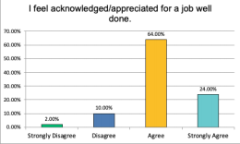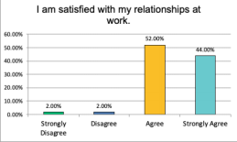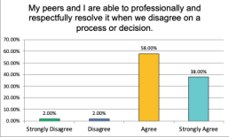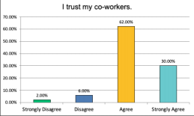

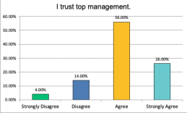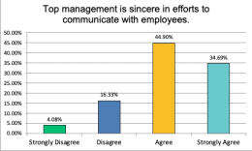Civility Partners, Inc, Climate Assessment, 2020 4

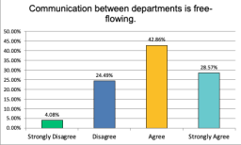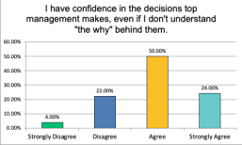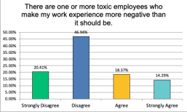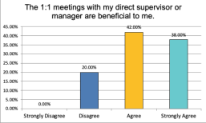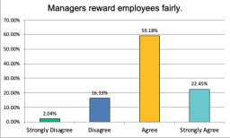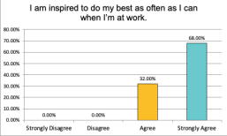Civility Partners, Inc, Climate Assessment, 2020 5

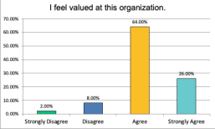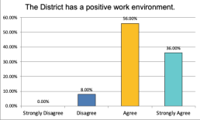Civility Partners, Inc, Climate Assessment, 2020 6

Civility Partners, Inc, Climate Assessment, 2020 7

Civility Partners, Inc, Climate Assessment, 2020 8

Civility Partners, Inc, Climate Assessment, 2020 9

Civility Partners, Inc, Climate Assessment, 2020 10

Civility Partners, Inc, Climate Assessment, 2020 11

Civility Partners, Inc, Climate Assessment, 2020 12

Civility Partners, Inc, Climate Assessment, 2020 13



Civility Partners, Inc, Climate Assessment, 2020 14



**OPEN-ENDED QUESTIONS: STRENGTHS**

**EMPLOYEES ARE ENGAGED**

● I look forward to coming to work every day.

● We have a great team. I am proud to work here.

● I would just like to thank Rainbow for the opportunity of working here.

● I like my Job, proud to be a part of RMWD and serve our rate payers!

● I feel nothing short of gratitude to work for RMWD. That gratitude motivates me daily to do whatever I need to get my job done and do it to the best of my ability.

**THE DISTRICT IS A GOOD PLACE TO WORK**

● RMWD is a great place to work, I have zero complaints.

● Great place to work, everyone gets along and is willing to help.

● overall great place to work, everyone is friendly and are willing to help out.

● Very happy at the district and how it’s run. Very impressed and inspired by my

supervisor and operations manager.

● Never experienced getting a hard time for balancing work and personal life which has been wonderful.

● My Pay+Benefits are really good for my position so much so that moving into a higher position elsewhere isn't worth the jump.

● Hopefully the survey input will be given sincere consideration so RMWD can continue to be a great place to work.

**EMPLOYEES APPRECIATE DISTRICT IMPROVEMENTS**

● Love the newsletter! It’s so fun!

● Satisfied how improvements are being made.

Civility Partners, Inc, Climate Assessment, 2020 15

● A couple months ago, I would have said I am completely burned out. So, I guess that is progress.

● Keep communicating with District employees regarding District changes or Board decisions San Diego Water Authority.

● Thank you for caring enough about Employees to send out this Survey. Many companies don't do this.

● The updates on the progress of the various large projects going on in the district and the opportunity to give input to the development of upcoming / future projects is greatly appreciated. Please continue to keep us updated and involved.

**THE DISTRICT RESPONDED WELL TO COVID-19**

● The District has been incredibly flexible with schedules to meet the additional needs posed by COVID.

● In talking to other people about their workplaces, RMWD is doing as well or better in responding to Covid-19. Our social tracking, notification and quarantine procedures are better than most.

● My personal and family life has never been better and that is because I work at RMWD and it provides me the work life balance that I've longed for. Especially this year through the pandemic and work from home/scheduling flexibility the District has offered. I couldn't be more grateful for my job.

**EMPLOYEES ARE SATISFIED WITH THE GENERAL MANAGER**

● Great job.

● Doing a good job.

● Keep doing what you're doing.

● Satisfied how GM is leading the district.

● Keep being awesome.

● Keep up the good work!

● He is an excellent and very intelligent leader.

● I am satisfied with the General Managers leadership.

● Just keep on doing what he’s doing seems to be working.

● I think Tom is doing a good job. He cares about our rate-payers and he supports employees' commitments to their families.

● Tom - your care for our Community and Ratepayers is real and genuine and very much respected. Please don't ever change that. I believe you also have a heck of a Management Team! A Dream Team, if you ask me! (...no I am not a Manager) but please take good care of the Management Team! They also deserve to be acknowledged for their hard work..!

● Continue doing what you are doing.

● Keep up the good work.

● Keep heading the right way. Make Rainbow a model other District's look up to. ● Continue to be transparent.

Civility Partners, Inc, Climate Assessment, 2020 16

**OPEN-ENDED QUESTIONS: OPPORTUNITIES FOR IMPROVEMENT**

**COMMUNICATION IS LACKING**

● Communications between top management and employees could be improved and be more free flowing.

● It'd be nice if managers make changes to processes and systems, if they'd follow up with the employees affected to see how things are working out.

● I feel there is still a bit of a missing link in communication between departments partially due to a desire for departments to "get the credit" for accomplishments.

**LACK OF TRUST BETWEEN EMPLOYEES/MANAGERS**

● Some managers are untrustworthy and do not provide proper responses. ● Management in Field Operations is very knowledgeable and trustworthy. Top Management in the rest of the areas are very knowledgeable but NOT trustworthy. ● I struggled to answer "I trust my co-workers.” That is a "somewhat agree" for me because the statement is so generalized. I trust SOME, but not all. Primarily because I don't know them very well, so many are new and with 2020 we hardly get to know one another on a deeper level than just identifying who they are by name and "hearing" from the grapevine if they are great employees or not.

**EMPLOYEES SEEK MORE GENUINE APPRECIATION**

● I do agree I am somewhat acknowledged for a job well done, I can't disagree with that, but It would be nice to receive genuine appreciation more on the spot or often. ● Acknowledgments of good work & praise of individuals are based on the relationships they have with said individuals or who that individual has a relationship in Top Management.

● Appreciation for a job well done is more often shared for new leadership team members and their departments with new employees as opposed to the smaller departments with seasoned employees who consistently work behind the scenes to support those employees who are acknowledged.

● Keep it up in general, but the way you (the general manager) praise some departments and make backhanded slights at others can be very demotivating. For example, "Engineers are Great, but Operations is where we get things done." This is very demotivating for an Engineering team that is working extremely hard and actually accomplishing a lot.

**INSTANCES OF TOXIC BEHAVIOR**

● [There needs to be] accountability for toxic Employees who are ungrateful and always look for something to complain or gossip about.

Civility Partners, Inc, Climate Assessment, 2020 17

● Any stray from a perfect score here is due to "locker room talk" that I hear amongst employees. I don't get the feeling that anyone is strongly hurt by the jokes I have heard, but they have not been dealt with in a way that makes me think there is zero-tolerance for it.

● There is one toxic person in Admin whom I and some others avoid interacting with. She seems to insert herself in matters that don't pertain to her and asks questions about why certain people aren't in the office more. I know at least one high-risk employee has felt pressured to come in more to avoid the passive-aggressive comments.

● To act more professional including the language that is used during meetings. (referring to top leadership)

**UNDERSTAFFED/HEAVY WORKLOAD**

● Workload often does not permit on the job learning and growth.

● Quantity of work and deadlines are overwhelming most times.

● My department has people with the right skills, but we are understaffed. ● Workload can get heavy. But other departments have been stepping up and helping out. ● It's hard to keep up with the workload. It does take 11-hour days and weekends to get the job done.

● Although it seems like there are never enough hours in the day to get everything done, we know we can count on each other.

**WORK LIFE BALANCE IS INCONSISTENT/LACKING**

● Work towards matching the workload with the philosophy of work life balance. ● Work expectations are high at the expense of work/home life balance. ● Invest in employees work life balance and that work goals/ expectations are realistic ● I have been given the advice that if I want time with my family, I should just sleep less.

These kinds of statements make me feel unsupported in balancing my personal responsibilities with my work responsibilities.

● I get a lot of "I don't care if you get the work done in 4 hours or 9 hours as long as the work is getting done" as a play at the notion that one could achieve balance by working extensively one day to earn time off later, but in reality there is always a backlog and never a point where the work is done.

● I would say that management says things like, "make sure to take time off and connect with your family." But when I have done that, I have been given feedback such as "weekends are for catching up on work" or "I deserve the respect of getting a response no matter when I email you."

**OPERATIONAL SUGGESTIONS**

● Add to Construction's fleet: Add another 5 yard dump truck and trailer and a skid steer with multiple attachments (sweeper, asphalt grinder, flat and teeth bucket); and add a third utility truck.

Civility Partners, Inc, Climate Assessment, 2020 18

● There is a notion that the Engineering Team should be persistent at pulling information and gathering comments from the Operations Department, which is great! But the folks in Operations need to be given the time to make comments and review the work Engineering is doing for that actually to be accomplished. The delay in getting comments out of Operations has halted many projects and made it very difficult to meet design schedules and Developer expectations. This is another example where the intention is GREAT, but the time needed to accomplish the intention is not being given.

**BE MORE INTENTIONAL ABOUT STAFFING**

● No succession plan is taken seriously enough. It's been a tough year. With a lot of regular work, projects, and COVID it's hard not to have some burnout.

● There are clear and specific deficiencies in some departments that are clearly overlooked due to the relationships that the individuals in that department have with Top Management.

● Learn more about what each role contributes to the operations of the district and encourage team members to help by learning how to do things other than their normal routine by thinking outside the box-don't leave it for others to do because they don't know how or why.

● When evaluating a position to look past the relationship they have with the individual in that position. Are they in that position to please Top Management or anyone that exerts influence in that department. Are the duties of that position being fulfilled, etc?

**MANAGEMENT COULD BE MORE RECEPTIVE TO IDEAS**

● Continue listening to fresh ideas and trying new methods for completing tasks. ● Keep open minded/ listen to the employees Ideas they might have.

● Ideas or concerns are treated as irrelevant and unimportant.

**RE GENERAL MANAGER**

● It would be nice to see him out in the field more often. comradery wise. ● Be more aware of the way daily and routine matters are handled by leadership and not just the big ticket stuff.

● Be more open minded.

● Trust his appointed Leaders. Trust the Managers and Supervisors on how they see their subordinates. They work with these individuals on a daily basis. The General Managers perceived bad experiences or great experiences with an individual does not take away the validity of the Managers/Supervisor's point of view of their subordinates.

**RE PERFORMANCE MANAGEMENT**

• I've only had two one-on-one meetings in the past year. They weren't performed even on zoom.

Civility Partners, Inc, Climate Assessment, 2020 19

● I thought we are all one team and have to work together to successfully reach our goals. However, I was also told that I received a satisfactory evaluation as opposed to something better for teamwork because I helped other departments too much. This is confusing messaging from upper management. Should I understand that if I want to go above and beyond in teamwork, I should do less of it?

● I feel that the tasks that stretch me and help me learn and grow have slowly been removed from my position over the last couple years.

**MISCELLANIOUS**

● While most coworkers take COVID seriously, there are a few who wear their masks incorrectly (let it fall below the nose), or walk around and socialize (unnecessary contact), or who take risks outside of work that could put the rest of us at greater risk. I wish they wouldn't do that.

● In recent years older employees have been pushed to retire earlier than desired by the employee.

Civility Partners, Inc, Climate Assessment, 2020 20